SlGH3.15, a member of the GH3 gene family, regulates lateral root development and gravitropism response by modulating auxin ﻿homeostasis in tomato
Ai et al

Supplementary Figures

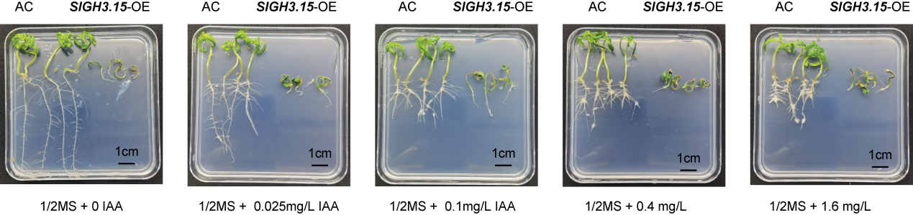
Figure S1 Root phenotypes of SlGH3.15-OE lines in response to exogenous IAA.
Root phenotypes roots in SlGH3.15-OE-10 and AC in response to the treatment of different IAA concentrations (n=4). Seeds of AC control and SlGH3.15-OE-10 line were germinated on ½MS-agar medium containing IAA at 0 mg/L, 0.025 mg/L, 0.1 mg/L, 0.4 mg/L, and 1.6 mg/L. The plates were maintained in a vertical position in a growth room for 14 days. Scale bar, 1 cm.

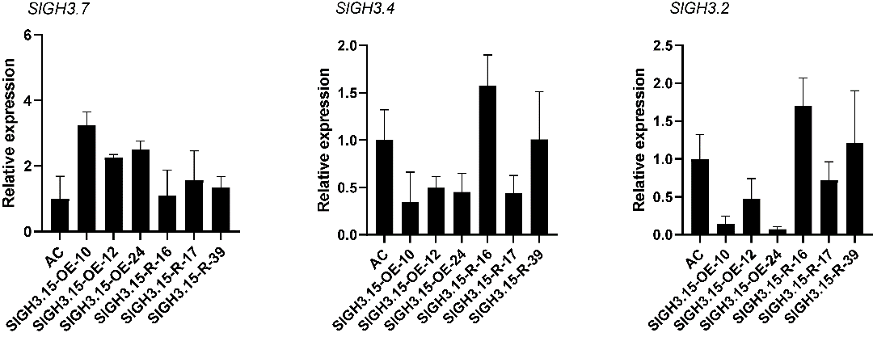
Figure S2 Relative expression of three GH3 family genes in SlGH3.15-transgenic plants.
To assess if the expression of paralogous genes of SlGH3.15 was affected by the expression level of SlGH3.15 in transgenic plants, three members of the GH3 family (SlGH3.2, SlGH3.4, and SlGH3.7) that are most closely related to SlGH3.15 in the phylogenetic tree (Figure 1C) were selected and assayed for their relative expression levels in SlGH3.15-OE and SlGH3.15-RNAi lines in comparison with the AC control (n = 3).

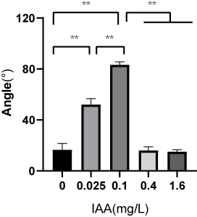
Figure S3 Angles of root apices in SlGH3.15-OE-10 in response to exogenous IAA treatments.
Angles of root apices along the gravity were measured in transgenic plants of SlGH3.15-OE-10 (Figure 5) in response to the exogenous IAA treatments from 0.025 to 1.6 mg/L. The asterisks indicate significant differences between groups based on Student’s t-tests: *, P < 0.05; **, P < 0.01.

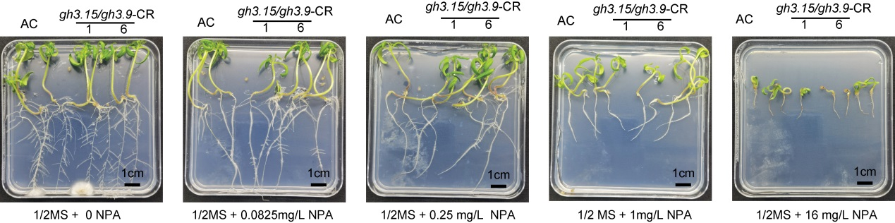
Figure S4 Root phenotypes of gh3.15/gh3.9-CR double mutant lines in response to NPA treatment.
Primary roots in gh3.15/gh3.9-CR and AC plants grown with different concentrations of NPA. Seeds of the double mutant lines and the control AC were germinated on ½ MS-agar medium containing NPA at the concentrations of 0 mg/L, 0.0825 mg/L, 0.25 mg/L, 1 mg/L, and 16 mg/L. Plates were kept in a vertical position in a growth room for 14 days. Scale bar, 1 cm.

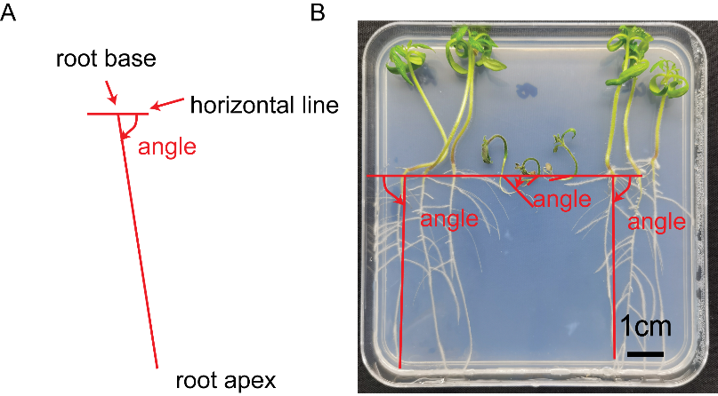
Figure S5 Measurement of angles for the root gravity.
(A) Schematic diagrams of angles of root apices along the gravity. Angles of root apices were defined as the angles between the horizontal line and the line from the root base towards the root apex. (B) Measurement of angles of root apices along the gravity in transgenic lines and AC control.

